CANADA

Canada is a country of fantastic natural scenery and diverse attractions. With its numerous national parks of untainted wilderness, you can easily find yourself literally hundreds of miles away from anything, in an environment of unparalleled beauty.
Wherever you decide to go in Canada, though, you will never be far away from breathtaking natural beauty, combined with an intriguing cultural heritage and friendly people.

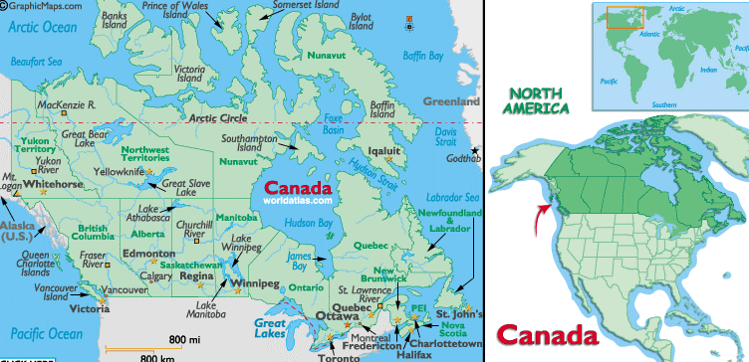

VISA : The visa is to be obtained prior to arrival in the country

REGIONS IN BRIEF:
It is divided into ten provinces plus three territories (Northwest, Yukon and Nunavut) to the North.
1. British Columbia
2. Alberta
3. Saskatchewan
4. Manitoba
5. Ontario
6. Quebec
7. New Brunswick
8. Nova Scotia
9. Prince Edward Island
10. New Foundland & Labrador
11. Yukon
12. Northwest Territories
13. Nunavut

HOW TO GET THERE:
Canada's major airline is Air Canada, providing air transportation nationally and internationally to more than 150 destinations. Smaller airlines such as West Jet, CanJet, Air Transat and Air North also connect you to destinations across the country. Direct flights connect the major cities of the globe with the larger Canadian airports, and frequent connecting flights will help you get to any Canadian destination efficiently.
From the U.S., direct flights whisk you from most major air terminals to many Canadian cities including Victoria, Vancouver, Calgary, Edmonton, Regina, Winnipeg, Thunder Bay, London, Toronto, Ottawa, Montréal, Québec City, Saint John, Halifax and Yarmouth.
Given Canada's immense size, and the relatively large distances between cities, it is a good thing that the transport system is as efficient and cost-effective as it is.

GETTING AROUND:
By Bus: A train or bus pass represents good value while flying is your best bet for covering large distances - particularly during winter when road conditions make long-distance driving a poor choice. Canada’s system of intercity bus routes spans the entire country. Greyhound is the largest provider of intercity bus services in Canada with over 1,000 locations in its network. Greyhound also offers convenient cross-border links to many U.S. cities.
Buses account for most of the fleets, but there are also streetcars, trolleys, sea buses, and trains. Major Canadian cities that offer subway, metro or light rapid transit service include Vancouver (SkyTrain), Calgary (CTrain), Edmonton (LRT), Toronto (subway), Ottawa (O-Train) and Montréal (metro).
One-way fares average around CAD$2-$2.25 per adult and can be purchased from subway/metro stations and some convenience stores. Cash fares can usually be substituted for transit tickets. Some cities also offer flexible transit passes so you can enjoy unlimited all-day, multi-day, or monthly travel.
By Train: Touring Canada by train is one of the most elegant ways to see the country. Virtually all of Canada’s major cities are connected by railroad and passenger rail travel is enjoying renewed popularity. The schedules and routes offered are limited in many areas, although if one is travelling in the Quebec-Windsor corridor, the train is quite an efficient means of transport - the fast train from Montreal to Toronto takes about four hours.
One can also use a Canrail pass, which entitles you to 12 days of unlimited travel in Economy class during a 30-day period. It will take several days to travel from coast to coast, but is a fantastic way to see the country.
All other rail tickets are sold in economy, senior, student or first class (known as VIA 1) and are available at station ticket counters.
The North America Rail Pass is valid thoughout the United States and Canada. Varieties of ticket permutations are available depending on the range and duration of your intended route.
Scenic & Luxury Rail Tours
Return to the golden era of rail travel on a scenic rail tour to some of the most spectacular and inaccessible terrain in the world—from glacial peaks to roaring rivers. You'll savor the views from the panoramic dome cars, taste gourmet meals in first-class style and even board a fleet of luxuriously appointed 1920s-era rail cars, conveyor of royalty, presidents and prime
From gourmet service in the Rocky Mountaineer’s custom-designed GoldLeaf Dome Coach to a trip back to a gentler era on the vintage cars of the Royal Canadian Pacific, romance of the rails is alive and well in Canada.
By Ferry: There are a number of ferry services operating between the mainland and the various outlying islands off the West and East Coasts.
British Columbia Ferry Corporation has a system running to Vancouver Island from various locations along the West Coast.
Out east in the Atlantic Provinces, there are several ferry routes to Newfoundland, Prince Edward Island, and Grand Manan (New Brunswick).

CLIMATE:
Spring, summer, and autumn are all ideal for touring, though if you want to ski you will have to visit in winter or early spring. For campers and those who want to visit the far north, the summer months of July and August are best. Summer is also when many of the country's festivals take place.
Note that the peak tourist season is between Victoria Day (late May) and Labour Day (early September). Although spring and autumn have fewer crowds, lower prices and a more relaxed pace than the summer months, some visitor-oriented facilities, and attractions may be closed during these shoulder seasons.
The western and eastern coasts are both very wet, though much of the rain falls during winter. In Saskatchewan, Manitoba and eastern Alberta the prairies are dry all year. Canadian winters are long and hard: in more than two-thirds of the country, the average January temperature is a shivering -18°C (-0.4°F). July and August are the warmest months, when temperatures in the south are usually in the upper 20°Cs (low 80°Fs).
Throughout most of Canada, there are four distinct seasons of winter, spring, summer and fall. However, the climate varies tremendously according to where you go.
During the course of the year, people in more southerly regions can easily experience a temperature range of -30°C to 35°C, whereas the far North has an arctic climate with frozen icecaps year-round.
Toronto, Vancouver and Victoria all tend to have mild winters (Dec-Feb), while cities such as Ottawa, Montreal and Edmonton are notorious for being extremely cold and having a high snowfall but you will find temperatures can vary a lot, even within one city.
Generally speaking summer (Jun-Aug) can be very hot, while spring and autumn (Mar-Jun, Sep-Nov) tend to be cool and comfortable and are usually regarded as the best times to visit.

VOLTAGE:
110-120V 60Hz

COUNTRY DIALING CODE:
+1

PUBLIC TELEPHONE:
Most public telephones are coin operated and cost approximately 25 cents per local call, though this varies according to the province. Some, though not all, telephones take phone cards, which can be bought at hotels and news stands.

LANGUAGES SPOKEN:
English, French

CURRENCY:
Canadian Dollar (CAD), Symbol: C$
Paper currency comes in denominations of five (blue), 10 (purple), 20 (green) and 50 (red). The brown C$100.00 bill and larger bills are less common and can be difficult to change.
Canadian coins come in denominations of one (penny), five (nickel), 10 (dime) and 25 (quarter) cent pieces. There are also the gold C$1.00 (loonie) and C$2.00 (toonie) pieces. The gold-coloured loonie features the loon, a common Canadian water bird, while the two-toned toonie is jauntily decorated with a polar bear.
It's best to change money at companies such as American Express or Thomas Cook/Travelex, which specialise in international transactions. If you can't find a money exchange office or booth, try a bank. American Express and Thomas Cook are the best travellers cheques to have, and you should make sure they are either in US or Canadian dollar denominations. Credit cards are widely accepted, especially Visa, MasterCard and American Express.
You will find ATMs in many grocery stores, malls, airports and so on, and most are linked to the international networks, the most common being Cirrus, Plus, Star and Maestro. You can also grab cash from an ATM if you use a major credit card although this method tends to be more expensive because, in addition to a service fee, you'll be charged interest immediately.
Be aware that shops and businesses rarely accept personal cheques, but credit cards are widely accepted (except perhaps in remote, rural communities where cash is king). Still, you'll find it hard or impossible to rent a car, book a room or order tickets over the phone without having a piece of plastic.

TIPPNG:
A tip of 10-15% of a restaurant bill is appreciated.

PROVINCES AND TERRITORIES:

BRITISH COLUMBIA:

Cities:
Vancouver, Victoria, Whistler, Kelowna

Vancouver:
The richest region in Canada, Vancouver looks every inch the wealthy and sophisticated metropolis that its reputation promises. Of course, besides the wealth of its inner city, reflected in the clean streets and fine architecture, its natural setting is one of the most beautiful for anywhere in the world.
Sitting on the unspoiled Southwest coast of Canada, even in the heart of downtown you are less than an hour away from whale-rich coastal waters and pristine beaches, and just a couple of hours from the snow-covered mountains of Whistler and Blackcomb, one of the world's most exclusive ski resorts. The city itself is divided by the wide water of False Creek, a constant stream of boat traffic that enlivens the city experience, especially so if you take the SeaBus that weaves in and out of the larger vessels as it travels between downtown and North Vancouver.
Vancouver International Airport is located 14km south of downtown, technically in Richmond
The Airporter Bus runs from the airport to major hotels in downtown as well as Canada Place and the train station from 06h30-23h00 each day. The Airporter runs two routes, dropping off at different hotels
Buses, sky train, Taxis are not overly numerous in Vancouver. You can usually catch them from ranks outside malls and larger attractions or hotels. If a taxi has its light on then it is available for hire and you can flag it down. Note that Vancouver's congestion causes problems at peak hours and you might be quicker trusting to the SkyTrain and your own two legs rather than a taxi.

MUST SEES:

Stanley Park:
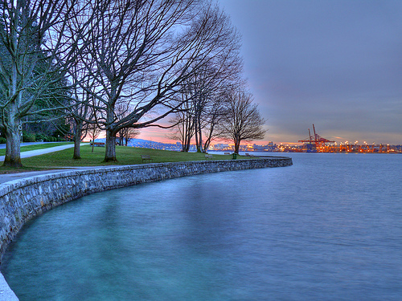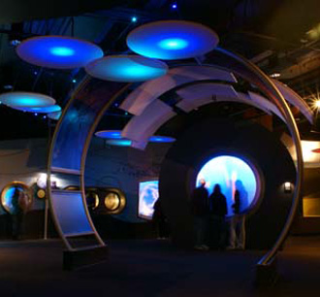

The verdant heart of this thriving city, Stanley Park is Vancouver's signature attraction. With over 1,000 acres of greenery, most of it dense West Coast forest, this is one of the largest urban parks in North America and the perfect foil to the big city. The sea wall that completely encircles the park is a popular promenade; you can walk it in around two hours or hire a bicycle or roller-blades

Vancouver Aquarium Marine Science Centre:
Located in Stanley Park, the aquarium is home to more than 60,000 creatures from the Arctic, Amazon tropics, and Canada's West Coast. The aquarium is most famous for its beluga whales, the rare white whales native to the Arctic.
Open: daily 0930-1900 (Jun-Aug); 1000-1730 (Sep-Jun)

Capilano Suspension Bridge:
Possibly the world's most popular toll bridge, spanning the Capilano River in North Vancouver this unlikely sounding attraction sees over three-quarters of a million visitors each year. Swaying 70 metres (230ft) above the canyon cut by the river, the narrow skyway was originally constructed in the 1880s by an intrepid Scottish engineer who merely used cedar planks and hemp rope.
Open: daily 09h00-17h00 (extended opening hours during the summer).

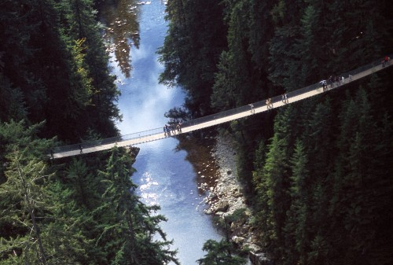

Vancouver Museum, Vancouver Maritime Museum

Granville Island:
Once an industrial wasteland Granville Island was transformed in a late-20th-century regeneration scheme to become one of the most popular leisure spots in Vancouver. With bohemian shops and stalls in its famous market and restaurants and cafés literally everywhere today, it's a honeypot for both residents and tourists alike.

Historic Gastown and the Steam Clock:
Gastown is one of the oldest suburbs of Vancouver. Today it has been restored to appear much as it must have done towards the end of the 19th century. Its cobbled streets and traditional warehouses were repaired and today are home to modern craft type shops and bohemian cafésand bars.

Grouse Mountain:
Grouse Mountain towers above Vancouver to the north and it is well worth making the journey out to take advantage of the attractions offered by the peak and its surroundings. From the car park at the bottom, you can ride the Grouse Mountain Skyride gondola nearly 3,000ft to the peak. On the way up and at the top you experience an unparalleled panoramic view of the city and harbour laid out below you.
Open: 09h00-22h00
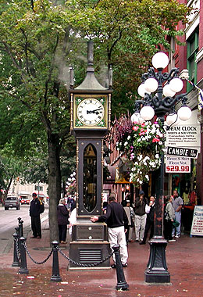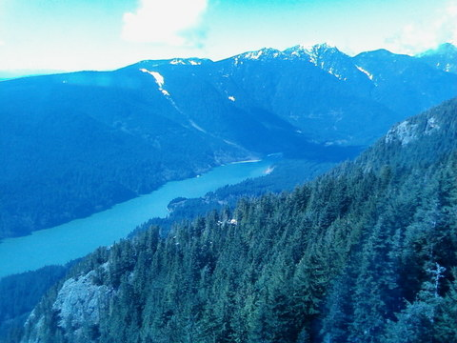

Pacific Science Centre:
This award-winning attraction offers the chance to journey through the cosmos without ever leaving terra firma. There are numerous things to see and do, from seeing the night sky above Vancouver in the planetarium to feeling as if you are travelling in space in the full motion spacecraft simulator

ALBERTA:
Cities:
Calgary, Jasper, Banff

Calgary is an attractive and dynamic city situated on the banks of the Bow River and close to Alberta's majestic Rocky Mountains. Calgary is a cosmopolitan city set in the rolling foothills of the western province of Alberta, which is located directly north of the State of Montana, USA.

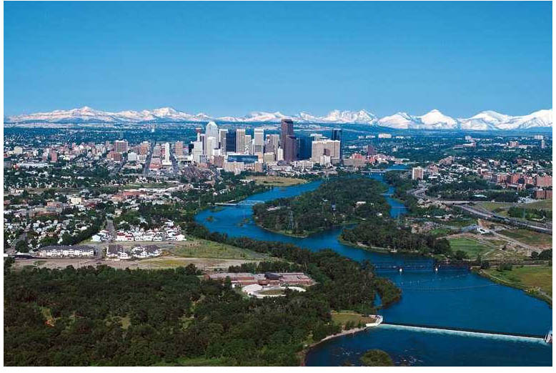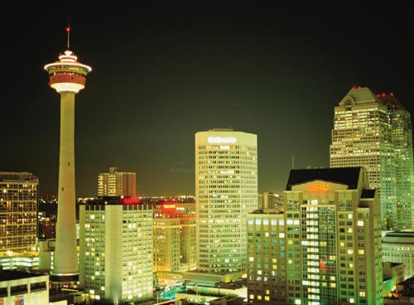

The majestic Canadian Rockies are less than an hour's drive from the city centre of Calgary. Calgary's International Airport is just a 20 -minute drive, (17 kilometers) from the city's centre. Excellent, well-maintained highways lead into Calgary from the United States and other parts of Canada.
Calgary is known for its sunny skies and a moderate four-season climate making it a travel destination for all ages. Alberta receives more hours of sunshine yearly than any other province in Canada. These wide-open blue skies and moderate climate beckons year-round outdoor enthusiasts from golfing to hiking, fishing to mountain biking, skiing to dog-sledding.

The Calgary Stampede:
The Calgary Stampede is undoubtedly Calgary's best-known visitor attraction. This event, featuring a large parade and world-class rodeo, draws more than a million people each year. Each year, millions of visitors from around the world come to Calgary to partake in the annual event, the Calgary Stampede and Exhibition. As Calgary's most popular tourist attraction, 'the greatest outdoor show on earth' features a real rodeo, a midway (amusement park), concerts, chuckwagon races and more. The city of Calgary is transformed for 10 days into town celebrating the cowboy culture. Visitors will enjoy the atmosphere and always friendly attitude of the locals. Calgary Stampede festivites begin with a downtown parade July 4.

Canada Olympic Park:
The host city of the 1988 Winter Olympic Games takes pride in its sporting legacy. Canada Olympic Park is a multi-purpose athletic facility designed for skiing, snowboarding, bobsleigh and luge during the winter and mountain biking during the summer. The Pengrowth Saddledome is the home of the NHL's Calgary Flames, as well as being the venue for countless events and concerts throughout the year.

Other attractions, including the Glenbow Museum, Calgary Tower and Eau Claire Market are other great places to visit year-round.

JASPER:

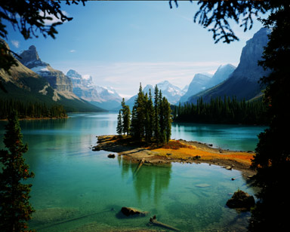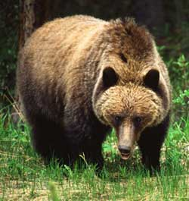

A quiet spot in the very heart of the Canadian Rockies, the little resort town of Jasper Alberta is a favorite spot to all who experience it. Explore these pages to discover the wealth of services and attractions available to make your trip to the Canadian Rockies memorable.
Deep in the Alberta Rockies, peaks crown the horizon in every direction. The vast majorities are pristine and will remain that way, preserved under the aegis of Canada's national parks system. Mountain sheep, bears, wolves, elk, and mountain goats have a secure home here, and can often be seen when simply driving down the road. To improve the chance of spotting a Grizzly bear, adventure seekers can opt for a hiking tour or explore the surrounding wilderness on horseback. But even from inside the car, the mountain views are spectacular. In particular, the road south of Jasper to Lake Louise is renowned for its breathtaking vistas. About halfway down, motorists often stop at the Columbia Icefield to view a still mighty but receding glacier, part of the Icefields Parkway and Eastern Slopes region. In the town of Jasper itself, visitors enjoy a peaceful small-town atmosphere, while chalets, B&Bs and famous Fairmont Jasper Park Lodge offer a wide range of accommodation often in building reflecting a distinct alpine architecture.

Lake Louise:
The lake owes its colour to fine particles suspended in the glacier waters, but few visitors at the world famous Fairmount Chateau Lake Louise are thinking of hydrology as they look out over the waters from the luxury hotel. Downslope from the Chateau, the town of Lake Louise has its own charm. Small but well-appointed with restaurants, accommodation and stores, the townsite is an ideal getaway destination in summer when trail riding, hiking, rafting and mountain biking predominate.Wildlife is also a major draw with elk commonly sighted from the road and even the occasional bear.

Jasper National Park:
Is the largest and most northerly Canadian rocky mountain national park, part of a spectacular World Heritage Site. It is located in the province of Alberta, to the north of Banff National Park and west of the city of Edmonton.. Comprised of delicate and carefully protected ecosystems, Jasper's scenery is none-the-less rugged and mountainous. In this special corner of Canada you can thrill to the thunder of Sunwapta Falls, enjoy the serene beauty of Mount Edith Cavell, connect with nature along 1,000-plus kilometres of trails, experience Athabasca Glacier up close or just resign yourself to a relaxing soak in Miette Hotsprings. The park includes the glaciers of the Columbia Icefield, hot springs, lakes, waterfalls and, of course, mountains. Wildlife in the park include elk, caribou, moose, mule deer, white-tailed deer, mountain goat, bighorn sheep, grizzly bear, black bear, be The largest glacial fed lake in the Canadian Rockies is found in Jasper National Park. Maligne Lake is 22 kilometres long and 97 metres deep. Aver, Rocky Mountain pika, hoary marmot and caribou
Jasper National Park is situated 370 km (192 mi) west of Edmonton, 404 km (256 mi) northwest of Calgary and 805 km (500 mi) northeast of Vancouver
Both Vancouver and Edmonton have regular Greyhound bus service to Jasper
Via Rail has regular train service to Jasper via Edmonton and Vancouver

Banff National park:
A rich history of the park dates back thousands of years before a 26 square kilometre national reserve was created around hot sulphur springs discovered near Banff. Today, the area has grown to 6641 square kilometres known worldwide as Banff National Park. Part of a complex chain of national and provincial parks and wilderness areas which together total 5 million acres set aside for posterity, it is one of the worlds largest protected domains. Vast glaciers rimmed with ice, huge forests, and emerald green lakes exhibit some of the most majestic mountain scenery on earth. Bears, wolves and a host of other magnificent animals and birds extend their range throughout the hinterland.
Discover a landscape rich in wildlife and history against a backdrop of glaciers and towering mountain peaks.
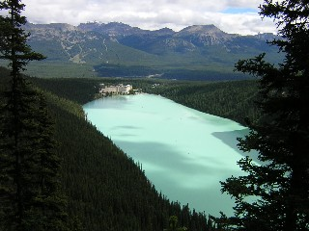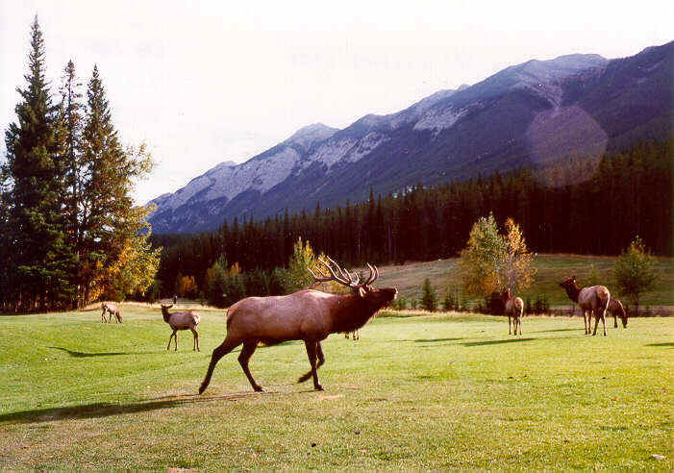

Discover Banff- The world famous resort town of Banff is located in the centre of Banff National Park, flanked on all sides by Alberta's Rocky Mountains. Countless visitors travel to the town each year, lured by the cozy resorts, unparalleled recreational opportunities and some of Canada's finest shopping and dining. Sunshine Village Ski Resort and Norquay are home to deep powder, deluxe mountain lodgings and some of the world's largest ski and snowboard events. The national park itself offers opportunities for mountain camping, hiking excursions and wildlife viewing. Banff has also built a reputation as a popular weekend retreat destination during the warm summer months. With renowned restaurants, decadent spas, eclectic boutiques and bustling nightclubs offering something for any taste, Banff has insured that guests will continue to visit the town year round..of valleys, mountains, glaciers, forests, meadows and rivers, Banff National Park is one of the world's premier destination spots.

Distances: Banff to Calgary 128 km
Banff to Jasper 287 km
Banff to Vancouver 850 km
There is direct bus service connecting downtown Calgary and the Calgary International Airport with the town of Banff and village of Lake Louise. There is also bus service connecting Banff and Lake Louise with the town of Jasper. Taxi service is available in Banff and Lake Louise. Several guiding companies also offer shuttle service to trailheads.

QUEBEC:
Cities: Montreal, Quebec City

Montreal:
Great French speaking metropolis entertains her visitors with some of the continent's most vibrant nightlife, stylish shopping and historic buildings. Add to this mix Canada's best museums and galleries and the largest programme of festivals in the country and you will understand why Montreal is an essential stop on any trip to North America's East Coast.

Montreal Dorval Airport (also known as Pierre Elliott Trudeau) is located 25km west of downtown Montreal. The city is also served by Mirabel Airport, some 50km north-west from the city, with some charter flights landing here.
By Taxi: Taxis are located outside the arrivals hall.
By Buses: L'Aerobus, Montreal's airport shuttle bus service runs every half hour from the arrivals terminal at Dorval to downtown Montreal central bus station and on to the Aerobus station. Services start at 05h00 and finish at 01h00. The journey takes approximately 45 minutes, dropping off at major downtown hotels. Tickets may be purchased from the above locations and from the kiosk outside the arrivals terminal or from the driver.
Dorval airport is also connected by STM (public transport) services. Bus 201 direction Montreal goes to Dorval bus station where you can change for bus 211 for Lionel Groulx metro station (located downtown).
Montreal public transport is run by STM (Societe de Transports de Montreal). STM operates an excellent four line Metro (subway) and a network of buses across the whole of Montreal Island. A single ticket can be purchased with exact change from bus drivers and Metro stations. This ticket is valid for one continuous journey by bus and metro.
Vieux Montreal:
The narrow cobbled streets of the old town are a picturesque reminder of Montreal's history as a thriving trading post. Quaint cafés and stylish boutiques are attractively located in historic buildings whose interiors have been stripped down to reveal the ancient brick. Horse-drawn carriages, called Calèches, are a popular way to soak up the atmosphere of the old town. They can be found waiting outside the two architectural highlights of the district, the stunning Cathedral of Notre-Dame and the gleaming dome of Bonsecours Market.
The 2.5km area of the old port was converted into a recreational park. Visitors in summer can stroll along the riverside watching the many outdoor performers who gather here. Winter sees an outdoor skating rink here, while the Science Centre and the IMAX Cinema offer family entertainment year round whatever the weather.

Notre Dame Basilica:
The basilica was constructed as recently as 1824, in Gothic revival style. The real beauty of the building is in its magnificent interior. The ceiling is a striking blue, adorned with gold stars. The stained glass is as good as any found in Europe and the religious artwork takes its inspiration from the Renaissance. Of particular note is the stunning altarpiece.
In season a spectacular Sound and Light show, reflects the cathedral off to stunning effect, although few noises can compete with the deep voice of the Gros Bourdon, the West Tower's single bell. The scale and beauty of the cathedral is a testimony to the Catholic devotion of the people of Quebec, and it has deservedly become famous throughout North America as one of the defining places of worship for the faith. Pope John Paul gave mass here in 1984, and the State Funeral of Canadian Prime Minister Pierre Elliot Trudeau was held here in 2000.
Open: daily 08h00-16h30.

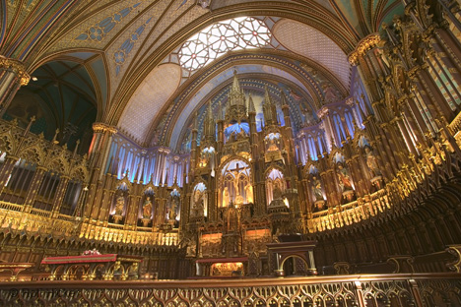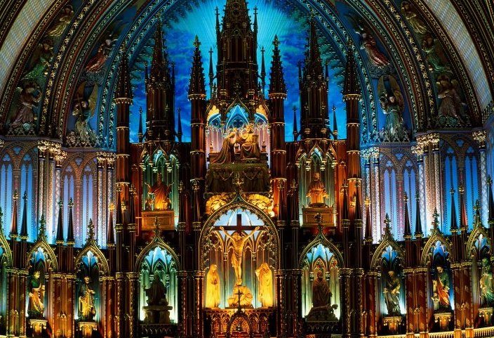

Pointe-A-Calliere - Montreal Museum of Archaeology And History
This award-winning museum complex is built on one of the earliest settlements in Montreal. The museum is divided into several different sections that an audio guide allows you to tour by yourself. Visitors follow a suggested route and staff members are on hand to give further explanations of the exhibits should you need them.
Open: Mon-Fri 10h00-18h00, Sat-Sun 11h00-18h00 (Closed on Mondays, and at 17h00 in winter).

Bonsecours Market:
Crowned by a 100ft-silver dome, this heritage building has been a Montreal landmark since its construction by the British in 1844. It is built on the remains of a succession of previous buildings, notably the home of the last French Intendent of Canada, and a 19th-century theatre that once hosted a performance by Charles Dickens in person.
During its lifespan the current building has served as city hall, and even briefly as Canada's Parliament, before being converted solely into a public marketplace. Today it primarily caters to tourists offering a range of souvenir stalls, art shops and pleasant café/restaurants. It's a popular spot to pick up presents for those back home.
Mount Royal Park This is Montreal's largest park, lying on and around the "mountain" that gave the city its name. The highlight of the park for visitors is the spectacular viewpoint - perched near the summit - that offers an unparalleled view over downtown Montreal. It's the best photo opportunity in town.
The Biodome:
The Biodome is one of Montreal's most unusual attractions, but continues to prove one of the city's most popular. Housed under the roof of the former Olympic Velodrome, the Biodome houses four ecosystems native to the American continent. Visitors walk straight into the heart of the Amazon rainforest, complete with howling monkeys, exotic birds, alligators and an ever-elusive sloth. The next room recreates the deciduous Laurentian forest, native to Quebec with an enormous beaver dam centrepiece.
The gallery offers an insight into the underwater world of the mighty St Lawrence River before sending you shivering into the Arctic to watch the playful antics of the resident penguin colony.
Open: Tue-Sun 09h00-17h00 (Open Mondays and until 18h00 in summer months).

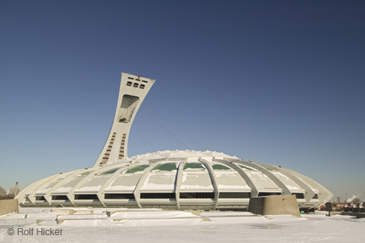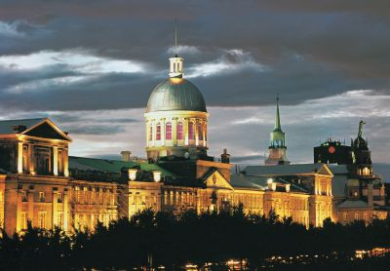

Other sightseeings in Montreal: McCord Museum of Canadian History, Olympic Park Botanical Garden.

ONTARIO:
Cities: Toronto

TORONTO:
With its distinctive skyline, punctuated by the exclamation mark of the CN Tower, Toronto sits on the shores of picturesque Lake Ontario, a shimmering jewel of a city.
Against the backdrop of the lake the city seems somewhat incongruous, and when pictured against the vast expanses of wilderness that form the majority of the rest of Canada this thoroughly modern city does seem something of an anomaly. But explore further and you'll find a city every bit as rewarding and appreciable as anything the rest of Canada has to offer.

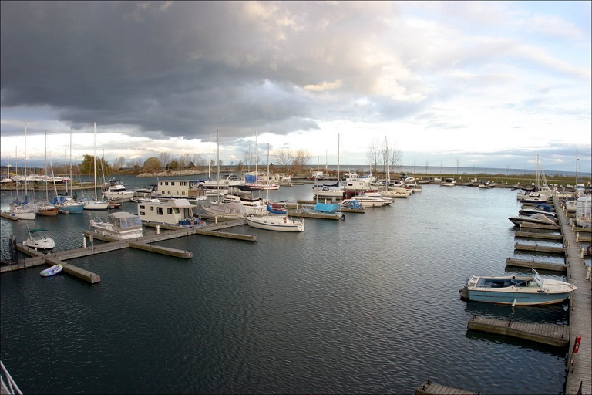

The largest and one of the liveliest cities in Canada it is hard to believe that Toronto for a long time had a reputation as something of a conservative, sleepy backwater of the British colonial empire. With a predominantly puritan population, through its early years the city was nothing like the energetic party town it is today. The colonial influence can still be seen in the administrative buildings of Old York Town and the Edwardian and Victorian buildings that survive in some of the city districts, notably the bohemian enclave of Cabbagetown. Despite this venerable heritage, Toronto has most definitely relaxed its stiff-upper lip into a welcoming smile.
The city is a lot more culturally and ethnically diverse than anywhere else in Canada. This is reflected in the many cultural quarters where you can get the flavours of the Far East, Africa or Europe within a couple of blocks of each other.

Royal Ontario museum:
The ROM is Canada's largest museum of culture and nature and a must-see for everyone. Permanent exhibits cover areas as diverse as Ancient Greece, an Egyptian mummy, native Canadian history, dinosaurs, a fabulous breakdown of precious gemstones, and a super section on how the Earth was formed that is designed for children but great for adults as well.
Throughout the year, concerts and special cultural theme nights are held on Friday evenings and Sunday afternoons. Located at 100 Queen's Park, at the corner of Bloor St West and Avenue Road, by the Museum subway stop on the Yonge-University line.
Open: Mon-Thu & Sat-Sun 10h00-18h00; Fri 10h00-21h30.

Art Gallery of Ontario
The superb AGO is the premier art collection in Toronto. The museum houses permanent exhibitions that range from European Old Masters to the early-20th-century Toronto collective, the Group of Seven, who defined a distinctive Canadian art movement of the period. There is also a large body of international modern pieces, including the world's largest public collection of works by British sculptor Henry Moore.
Open: Wed-Fri 10h00-21h00; Sat-Sun 10h00-17h30.

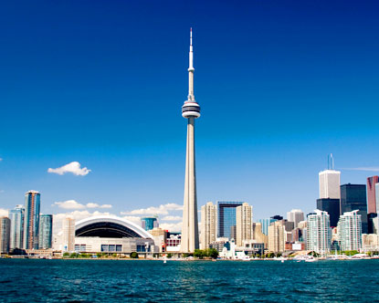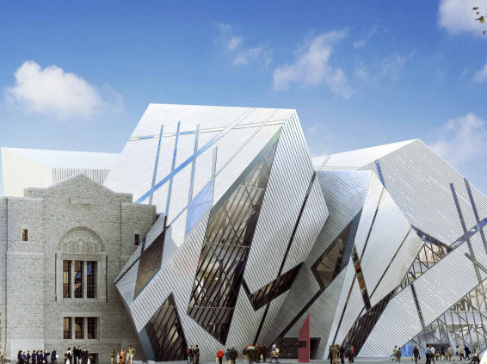

CN Tower:
This landmark is how the city of Toronto's skyline is recognized the world over and it's impossible to miss on a trip to the city. One of the world's tallest buildings it reaches 553.3m (1815ft 5in) into the air, and offers a fabulous view of the city on a fine day.
The ride up and down the glass elevator and jumping on the glass floor in the observation tower is a lot of fun, but not recommended for those scared of heights. There is a revolving restaurant that allows you to sit and enjoy the full 360° view of the city as you dine. An arcade, theatre, and gift shop occupies the base.
Open: Sun-Thu 09h00-22h00; Fri-Sat 09h00-22h30

Toronto islands:
The Islands offer a tranquil escape from the bustle of the city and the view of Toronto back across the sound is rendered rather surreal due to the rural quiet of the islands.
The Toronto Islands have no roads, are accessible only by ferry and are thus the perfect escape for a picnic and a leisurely stroll. Some of what you will find includes volleyball and tennis courts, a park, beaches and numerous snack bars. But you should be forewarned of the nudist beach before you start roaming around! If you don't fancy walking, bring your own in-line skates or rent a bicycle on the island.

Harbourfront:
The Toronto Ferry Dock is located at the foot of Bay Street and Queens Quay, just west of the Weston Harbour Castle Hotel. Take the streetcar or bus to Queen's Quay. Ferries take you to Ward's Island, Centre Island or Hanlan's Point
The water's edge of Lake Ontario offers so much when the weather warms up (April-October). Visitors and locals alike can be found strolling down the waterside promenade, taking time to stop in the galleries, theatres, craft boutiques, restaurants, and cafés.
There are a number of options for making the most out of the waterfront; you can sign up for sailing lessons, roller blade along the boardwalk or simply soak up the relaxed ambience. Weekends really draw in the crowds with amazing craft kiosks and free open-air cultural concerts and exhibitions.

The Beaches:
The Beaches is a laid-back neighborhood filled with restaurants and bars, fun shops and quaint antique stores lining the waterfront of Lake Ontario.
From May to October, you will find all sorts of people in-line skating, biking, jogging, and walking their dogs along the boardwalk while others frolic in the sand and a few fly enormous kites. During long weekends between May and September, there are class-act free pop and rock concerts and in July you will find the free Jazz Festival in Kew Gardens.
To get to the Beaches, take the Queen St streetcar east about 20 minutes to Woodbine Ave
Excursions from Toronto

EXCURSIONS:
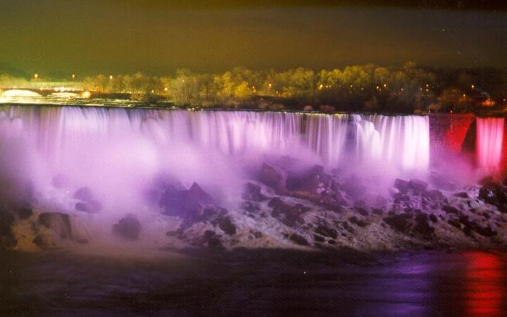

Niagara Falls:
A short distance outside the city you will find Niagara Falls in its entire touristy splendour. It is an easy drive or inexpensive bus ride from Toronto and you'll be rewarded with one of nature's most powerful spectacles. Niagara is especially impressive at night-time when the falls are floodlit.
Get the best out of Niagara by taking one of the boat cruises right into the horseshoe, where you can feel the spray from the thousands of gallons of water that continuously crash down over the precipice. You will get wet, and the noise is deafening, but the views make it worthwhile.
Niagara-on-the-Lake nearby is a beautifully quaint small town in the heart of a region that boasts some of the world's best wineries.

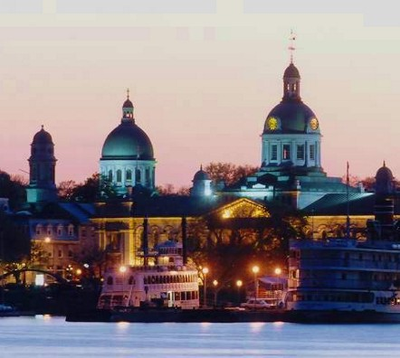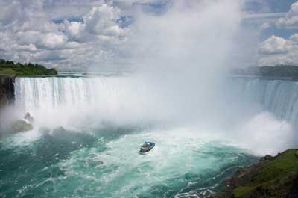

Kingston:
Kingston, the "Limestone City", is a beautiful historic town 250km from Toronto. At one time this, the oldest city in Ontario, was Canada's capital. It is now renowned as a historical and cultural centre, where three centuries of Canadian tradition is preserved.
There are some excellent examples of Victorian architecture still existent in the city centre, and many of them are open to the public. What Kingston is most famous for though, is the fabulous paddles teamers that leave the port for the Thousand Islands that sit at the mouth of the St Lawrence river. Taking a cruise is a definite must on a visit here.
The nearby Fort Henry was built during the war against the Americans in 1812 and is well worth a visit. The Fort Henry Guard, still resplendent in their British "Redcoat" uniforms recreate the real atmosphere of a 19th-century military garrison, with formal marching and cannon displays

Algonquin National Park:
Three hours by road from Toronto, Algonquin National Park is a vast expanse of protected Canadian wilderness. Covering 7700 square kilometres as you might expect the park contains a great diversity of topography, flora and fauna.
Canoeing down one of the many rivers is a popular way to explore areas of the park, and the lucky few will see some of the more elusive inhabitants of the park which include the giant Canadian moose and wolves. Cycling or hiking trails explore the park further, and it is possible to camp deep in the interior, far from civilisation.
For the less adventurous, the Parkway Corridor, along Highway 60, which runs across the Southwest of the park, is lined with campsites that give you a taste of Canada's broad wilds, without venturing too far from the beaten track.

SHOPPING:
North America in general tends to be cheaper than Europe for many items, especially fashion. Casual and sportswear tend to dominate the scene, and you will find some good buys if you are looking for fleeces, jeans, or trainers. Roots, the Canadian equivalent of Gap, sell men and women's clothes and shoes as well as household goods in some larger branches. MAC cosmetics, founded in Toronto and a favorite in the fashion industry, can be found throughout the country and tend to be cheaper in Canada than elsewhere.
For something quintessentially Canadian, pick up a "toque" (pronounced "took" with a long "O" sound, rhyming with "fluke'.). This is a pull-on winter hat, which will keep out the cold when you're venturing out into the freezing cold Canadian winter.
In many areas, you will find talented local artists. Keep an eye out for native Canadian artifacts: you can pick up some unique knick-knacks, which make ideal souvenirs, such as dream catchers or sandstone carvings. Traditional jewellery and clothing, such as moccasins, are also worth looking out for.
To take a taste of Canada home with you, pick up a Canadian bottle of wine, beer from a local brewery or some smoked salmon.
Of course there is a plethora of flags, badges and pens with maple leaves emblazoned on them if you want people to have no doubt as to where you've been. To be a little more original, many souvenir shops also sell T-shirts, key rings and the like, decorated with Mounties, moose or beavers
Shops are generally open Mon-Sat from 10h00-18h00. Some shops are open on Sun but for a shorter period. In major cities supermarkets are usually open from 07h30-21h00.

TAX REFUND:
There is a national tax, the GST (Goods & Service Tax) of 7% that is charged across the country except for the purchase of basic groceries. Each province then charges an additional 6% to 14% PST (Provincial Sales Tax) along with the GST. The Eastern provinces have an amalgamated Sales Tax of 15% while every other province from Quebec west will break down the GST and PST for you. So the price you see is rarely the total amount. Expect the final prince at shops, bars and restaurants to be approximately 15% more than that stated.
You can obtain a GST refund on purchases taken out of the country and on short-term hotel accommodation. Rebate forms, which, along with all your original receipts, must be submitted within 60 days of leaving Canada, are available from some shops, Customs or the Canadian tax office. To be eligible for a refund, receipts must total at least CAD200.
Some duty-free shops issue an instant refund of up to CAD500 cash on leaving the country and most provinces do not tax goods that are shipped directly out of the country by the retailer

